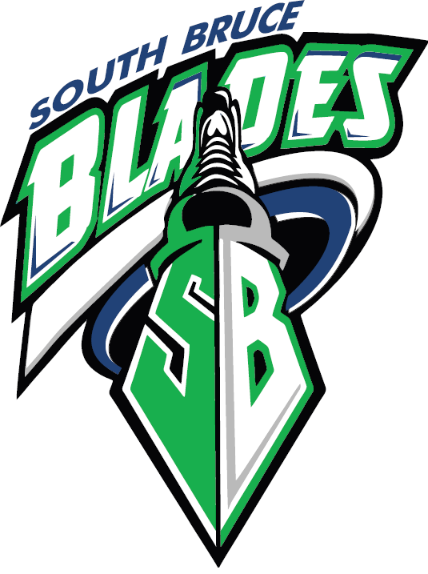

Coaches’ Guide
This information booklet has been created to help you as a Coach with South Bruce Minor Hockey Association. We hope that this will make your volunteer job as a Coach easier. Thanks for your dedication and time committed to the kids of South Bruce Minor Hockey. Good luck to you and your team this season!

2015-16 SBMHA Executive & Staff
This information can be found at www.southbruceminorhockey.ca under Contact Us

It takes a team to make a team...
The following are some of the volunteer positions that each team may have. It is recommended that these positions be filled early in the season. Some of these jobs may be combined roles – however we encourage all parents to take on a role. Many hands make light work.
All Coaching staff (anyone on the bench or on the ice for practices) must have:
- OMHA certification for their position on the bench
- Speak Out (PRS) or RIS (Respect In Sport) certification
SBMHA will reimburse Coaching Staff for any certifications required provided it is approved by the Coaches Committee. Please visit www.omha.net for a list of Clinics and get registered as early as possible. For those coaches who need to re-certify, the deadline is August 31st of each year. Please make sure you have the proper certifications. If you have any questions, please contact the Coaches Committee Chair.
Coaching Staff should include:
1. Head Coach
2. Assistant Coach
3. Trainer
4. Manager
Team Staff should include:
1. Parent Rep – liaison between Parents and Coaching Staff
2. Website Rep – update scores and submit news articles on team website
3. Public Relations Rep – submit photos and write-ups to local newspaper

Checklist for a Successful Season:
1. OMHA Code of Conduct – visit www.omha.net and review the OMHA’s policies, rules and regulations
2. Tryouts – are held in the fall of each year. Each age group will have a total of 3 ice times to conduct tryouts. SBMHA strongly suggests using 3 Evaluators who have no relation or perceived bias toward the players on the ice being evaluated. Players are to be notified after tryouts of which team they have been selected to play for using an envelope and standard letter that is included in this package. Please ensure that parents and players open the envelopes away from the Arena.
3. New Players – must be registered before stepping on the ice. This is for insurance reasons only. If a player is not registered, please ask them to leave the ice and contact the Registrar.
4. Roster – send the list of Coaching Staff and Players Names to the appropriate OMHA or OWHA Contact as soon as the team has been selected so that team rosters can be approved by the OMHA/ OWHA. Carry your approved roster with you to all games, tournaments and playoffs.
5. Affiliated Players – are players that are signed to the team roster from other teams in case of situations when extra players are needed (i.e. Sickness, injury, suspensions, etc.) You are encouraged to have 2-3 Affiliate players for your team in case you are ever short of players. “Offer of Affiliation” forms are included in this package and are to be used for Affiliate players. Signatures are required by the player, parent, Coach of the Player’s registered team, Coach of the team offering Affiliation and the OMHA Contact or SBMHA President. The list of Affiliate players should be submitted to the OMHA Contact no later than Nov. 30th for OMHA approval.
6. League Scheduling Meetings – is held in late September or early October each year in Wingham. This meeting brings together all coaches to schedule games for the year. Please have a Representative from your team attend this meeting. Meeting dates and times will be posted on the website and communicated to each team by the Town Contact. Before the scheduling meeting, the Ice Convenor will give each team a schedule of home ice times. After the scheduling meeting, it is the Coach/Manager’s responsibility to advise the Ice Convenor, Referee-in-Chief, Door Keeper and Food Booth Chair of your team’s season schedule.
7. Tournaments – a list of scheduled tournaments is available on the OMHA / OWHA websites. It is strongly recommended that teams book tournaments as soon as possible as they fill up quickly. Please try to enter each team into at least one tournament throughout the season.

8. Parents Meeting – will be conducted at the start of each season to communicate the
Coaching Staff’s intentions for the year. Coaches should discuss such issues as: team rules, disciplinary actions, expectations of players and coaches, ice time management, practice plans, affiliated players, dress code, tournaments, playoffs and team functions. A sample Parents Meeting agenda has been attached which can be modified to meet your team’s needs.
9. Cancelling or Changing Ice times – if you are required to change/cancel ice time, you
are required to contact the following people... a) Carl Kennedy – Ice Convenor - 519-392-6139 – mugsy@hurontel.on.ca b) Mildmay Arena – 519-367-2624 or Teeswater Arena – 519-392-6902 c) John Turnbull – Referee in Chief – 519-889-1080 – mildmayrefs@live.ca d) Maddy Bester – Door Keeper/Time Keeper – 519-367-2790
Nancy Berwick-Door Keeper/Time Keeper- 519-392-8359 e) Heather Collins – Food Booth Chair – 519-392-8679
• Please note that the Arena requires 48 hours’ notice of a cancellation (unless it is due to inclement weather) or SBMHA will be charged for the use of that ice time.
10. Referees – must be present at all games, regardless of level. If a Referee is not present, the coach is putting SBMHA at risk of some major suspensions. Please notify the Referee in Chief (John Turnbull) of any games scheduled, cancelled or changed. It is important to book referees and to cancel them if necessary. Please have someone from your Coaching Staff check with the Door Keeper at least 15 minutes before the scheduled game time to ensure the referees have signed in. If you have no referees 15 minutes before a game, please contact the Referee in Chief/or Assistant Referee-in-Chief
11. Practices – should be well-planned and organized. SBMHA strongly recommends that coaches be prepared, have a plan for each practice and use the ice time wisely (scrimmaging is easy to do but not great for individual skill development – keep scrimmaging to a minimum). There are several resources available for practice plans including Hockey Canada’s Development Guide. Please note that players are only allowed to practice with the age group they are registered with or affiliated with (i.e. an Atom player cannot practice with the Pee Wee LL or Pee Wee Rep team unless they are affiliated with that team)
12. On-Ice Volunteers – can be used during practices provided they are registered with SBMHA. If they are not registered with SBMHA in the current year as a player or bench staff, they are not insured. All on ice helpers must be at least 2 years older than the group they are helping with. Players between the ages of 9-14 must wear full equipment. All coaches and helpers on the ice must wear an approved helmet and hockey gloves. All volunteers (including a player volunteer) must sign the On-Ice Volunteer form which is submitted to the OMHA along with the fee (which is paid by SBMHA).

13. Equipment – see the Equipment Manager for a key/ combination to your team’s locker. Please keep your locker and team jersey’s clean and tidy throughout the season. Coaching Staff are responsible for their team jerseys – please do not let players take jersey’s home or use them for practices. Each team is provided with a First aid kit. Please ensure your Trainer has the necessary inventory in the kit at all times. At season’s end, please have your team’s jerseys washed and returned to your team’s locker. Any lost or damaged jerseys will be the responsibility of the Coaching Staff.
14. Game Sheets – will be provided to each team by the OMHA / OWHA Contact. The white copy of each game sheet should be left in the Referee’s room and will be forwarded to the WOAA office by a designated person.
15. Playdowns / Playoff Contracts – will be required to be signed between opposing teams before the first game of each series. Please ensure all information is correct and forward to the OMHA / OWHA Contact. Please make special note of the Gate Fee which varies from centre to centre. It is strongly recommended that both centres charge the same Gate Fee in a playoff series.

Sample Parent Meeting Agenda
Introduction (5-10 minutes)
- Introduce manager, coach, assistant coaches, trainer, etc.
- Give a brief explanation of the importance and purpose of the meeting.
Coaching Overview (10 minutes)
- Have the Coach provide information on the goals and objectives for the season and credentials and philosophy.
Details of Program / Expectations for Players (10-20 minutes)
- With the Coach present specific information on the operation of your hockey program.
- Overview of how coach and player evaluations will be implemented.
- Discuss expectations of the player (and parents) Fair Play Code
- Time commitment, game & practice expectations
- Respect for themselves, all players (own team and opposition), referees, officials, parents, etc.
- Expected conduct – games, practices, locker room, events
- Discipline
  - Let parents participate in deciding rules of parent conduct at games, team functions, etc.
Budget (15 minutes)
- Outline of expected costs , tournaments
- Extra activities – social events, photos, extra tournaments, extra ice time to be booked?
Team Apparel (5 minutes)
- Discuss dress code
- Water bottle policy
Expectations of the Parents / Volunteers (20 minutes)
Organize a parent’s committee to coordinate roles and responsibilities – volunteer roles
Parent Rep, Emergency Contact, Responsibility List
Questions (5 minutes)
- Allow additional questions, parent concerns, etc.
- Distribute materials and any forms that need parent’s attention.

